### **Git is a free, open source distributed version control system.**

### **Version Control** is the management of changes to documents, computer programs, large websites and other collection of information.

## There are two types of VCS:

* Centralized Version Control System (CVCS)
* Distributed Version Control System (DVCS)

### **Centralized VCS**

Centralized version control system (CVCS) uses a central server to store all files and enables team collaboration. It works on a single repository to which users can directly access a central server.

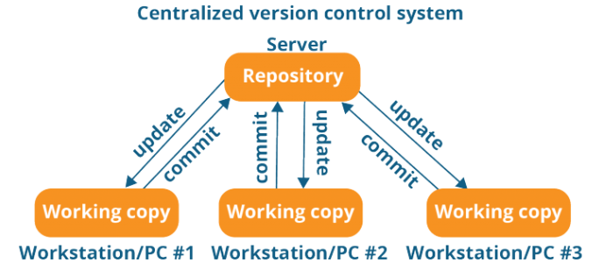

Every programmer can extract or update their workstations with the data present in the repository or can make changes to the data or commit in the repository. Every operation is performed directly on the repository.

Even though it seems pretty convenient to maintain a single repository, it has some major drawbacks. Some of them are:

* It is not locally available; meaning you always need to be connected to a network to perform any action.
* Since everything is centralized, in any case of the central server getting crashed or corrupted will result in losing the entire data of the project.

This is when Distributed VCS comes to the rescue.

### **Distributed VCS**

These systems do not necessarily rely on a central server to store all the versions of a project file.

In Distributed VCS, every contributor has a local copy or “clone” of the main repository i.e. everyone maintains a local repository of their own which contains all the files and metadata present in the main repository.

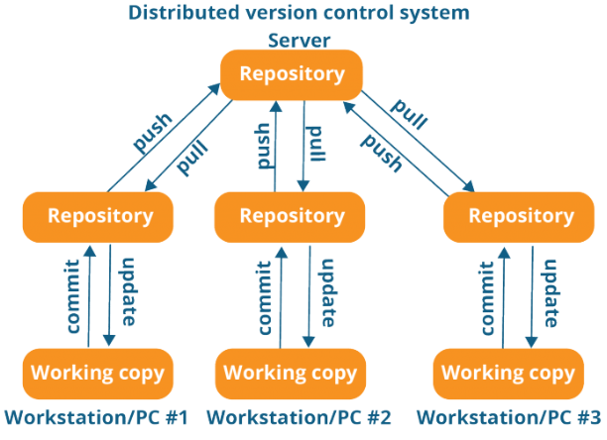

Every programmer maintains a local repository on its own, which is actually the copy or clone of the central repository on their hard drive. They can commit and update their local repository without any interference.

They can update their local repositories with new data from the central server by an operation called “pull” and affect changes to the main repository by an operation called “push” from their local repository.

## **Git Commands**

### **git config**

Usage: git config –global user.name “[name]”

Usage: git config –global user.email “[email address]”

This command sets the author name and email address respectively to be used with your commits.

### **git init**

Usage: git init [repository name]

This command is used to start a new repository.

### **git clone**

Usage: git clone [url]

This command is used to obtain a repository from an existing URL.

### **git add**

Usage: git add [file]

This command adds a file to the staging area.

Usage: git add *

This command adds one or more to the staging area.

### 

### **git commit**

Usage: git commit -m “[commit message]”

This command records or snapshots the file permanently in the version history.

Usage: git commit -a

This command commits any files you’ve added with the git add command and also commits any files you’ve changed since then.

### **git diff**

Usage: git diff

This command shows the file differences which are not yet staged.

Usage: git diff –staged

This command shows the differences between the files in the staging area and the latest version present.

Usage: git diff [first branch] [second branch]

This command shows the differences between the two branches mentioned.

### **git reset**

Usage: git reset [file]

This command unstages the file, but it preserves the file contents.

Usage: git reset [commit]

This command undoes all the commits after the specified commit and preserves the changes locally.

Usage: git reset –hard [commit] This command discards all history and goes back to the specified commit.

### **git status**

Usage: git status

This command lists all the files that have to be committed.

### **git rm**

Usage: git rm [file]

This command deletes the file from your working directory and stages the deletion.

### **git log**

Usage: git log

This command is used to list the version history for the current branch.

Usage: git log —follow [file]

This command lists version history for a file, including the renaming of files also.

### **git show**

Usage: git show [commit]

This command shows the metadata and content changes of the specified commit.

### **git tag**

Usage: git tag [commitID]

This command is used to give tags to the specified commit.

### **git branch**

Usage: git branch

This command lists all the local branches in the current repository.

Usage: git branch [branch name]

This command creates a new branch.

Usage: git branch -d [branch name]

This command deletes the feature branch.

### **git checkout**

Usage: git checkout [branch name]

This command is used to switch from one branch to another.

Usage: git checkout -b [branch name]

This command creates a new branch and also switches to it.

### **git merge**

Usage: git merge [branch name]

This command merges the specified branch’s history into the current branch.

### **git remote**

Usage: git remote add [variable name] [Remote Server Link]

This command is used to connect your local repository to the remote server.

### **git push**

Usage: git push [variable name] master

This command sends the committed changes of master branch to your remote repository.

Usage: git push [variable name] [branch]

This command sends the branch commits to your remote repository.

Usage: git push –all [variable name]

This command pushes all branches to your remote repository.

Usage: git push [variable name] :[branch name]

This command deletes a branch on your remote repository.

### **git pull**

Usage: git pull [Repository Link]

This command fetches and merges changes on the remote server to your working directory.

### **git stash**

Usage: git stash save

This command temporarily stores all the modified tracked files.

Usage: git stash pop

This command restores the most recently stashed files.

Usage: git stash list

This command lists all stashed changesets.

Usage: git stash drop

This command discards the most recently stashed changeset.

## 